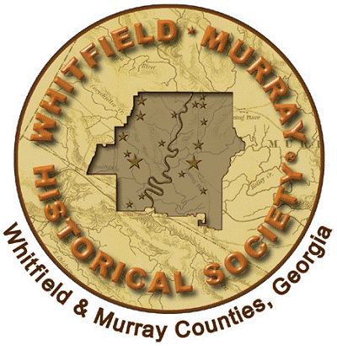
Whitfield-Murray Historical Society
P.O. Box 6180
Dalton, GA 30722
706-278-0217
FOR OFFICE USE ONLY
Date Rec’d_________
Category__________
Entered___________

“HOMECOOKED HERITAGE”
Recipe Submission Form

The Whitfield-Murray Historical Society is planning a new cookbook! “Homecooked Heritage” will feature recipes that have been passed from generation to generation by local families. Included with these recipes will be stories, fond memories and photographs related to each recipe, and interesting vintage ads from area businesses.
“Homecooked Heritage” is sure to be a unique blend of local history and good eats. Copies of this book will be available in the fall of 2010 –just in time to make wonderful Christmas gifts! Proceeds from the sale of this book benefit the Historic Hamilton House fund. Please use this form to submit your recipes and memories today! Submit as many recipes as you like, but please us a separate form for each. Copy this form as needed.

◦CONTACT INFORMATION (Person submitting material)
Name___________________________________________________________
Mailing Address_________________________________________________
City________________________ State______________ ZIP______________
Phone:___________________________Email:_________________________

◦RECIPE INGREDIENTS (Please be sure to include amounts for each ingredient and specify any substitute or optional ingredients)

________________________________________________________________________________________________________________________________________________________________________________________________________________________________________________________________________________________________________________________________________________________________________________________________________________________________________________________________________________________________________________________________________________________________________________________________

◦INSTRUCTIONS FOR PREPARING RECIPE
______________________________________________________________________________________________________________________________________________________________________________________________________________________________________________________________________________________________________________________________________________________________________________________________________________________________________________________________________________________________________________________________________________________________________________________________________________________________________________________________________________________________________________________________________________________________________________________________________________________________________________________________________________________________________________________________________________________________________________________________________________________________________________________________________________________________________________________

◦RECIPE HISTORY
Please include information such as how you obtained the recipe, from whom it was obtained, fond memories you have related to this recipe or the person(s) from whom it came, any special occasions (holidays, church homecomings, etc.) when this recipe was/is usually served, when you obtained the recipe, etc. Please make sure that the recipe has some connection to Whitfield or Murray County.
_________________________________________________________________________________________________________________________________________________________________________________________________________________________________________________________________________________________________________________________________________________________________________________________________________________________________________________________________________________________________________________________________________________________________________________________________________________________________________________________________________________________________________________________________________________________________________________________________________________________________________________________________________________________________________________________________________________________________________________________________________________________________________Please attach additional sheets if necessary.
◦PHOTOGRAPHS
Please include any color or black and white photographs that relate to the recipe(s) you submit. For example, you may wish to include a photograph of your Grandmother who showed you how to make homemade fried apple pies or you may have an old photograph from a church homecoming where a slice of that special cake was always a must have. Please send clear COPIES of your photographs either in hard copy form, on a disc, or by email (wmhs@optilink.us). Do not send original photos as PHOTOS WILL NOT BE RETURNED.
Information regarding photograph(s): (include any dates/names you have)
________________________________________________________________________________________________________________________________________________________________________________________________________________________________________________________________________________________________________________________________________________________________________
Number of photographs submitted with this recipe
◦CREDITS
Please print your name and city of residence as you would like for it to appear with your published recipe. For example: Jane Doe, Dalton, Georgia or The John T. Doe Family, Spring Place, Georgia
__________________________________________ ___________________________________
Name City, State

PERMISSION TO PUBLISH OR REJECT
I hereby give the Whitfield-Murray Historical Society permission to publish the above submitted information and/or photographs in “Homecooked Heritage” or any subsequent publication. I also give the Society permission to edit all or any portion of the above submitted information for clarity and format and realize that submitting this material does not guarantee that it will be included in the final publication.

_____________________________________________ ___________________________
Signature of Person Submitting Materials Date

Please mail this completed form to: Whitfield-Murray Historical Society
Cookbook Project
P.O. Box 6180
Dalton, GA 30722

